# 1. Server Selection

Some developers want to deploy their application on different servers with a load balancer in the front. There are n servers to choose from where the number of requests that can be handled by the ith server is server[i]. The number of requests served by any server is a power of 2 i.e. 1, 2, 4, 8, 16,...etc.

Given the array server and an integer expected_load, find the minimum number of servers that must be chosen such that the total sum of requests served by all the chosen servers is exactly equal to the expected_load. If there is no combination of servers that can serve exactly expected_load requests, report -1 as the answer.

**Example**

Suppose n = 4, servers = [1, 1, 2, 4], and expected_load = 3.

It is optimal to choose the first and the third or the second and the third servers serving a total of 1 + 2 = expected_load = 3 requests. Return the minimum number of servers needed, 2.

**Function Description:**

Complete the function getMinServers in the editor below.

The function getMinServers has the following parameter:

    int expected_load: the number of requests to be served

    int server[n]: the number of requests the servers can serve

**Return**

    int: the minimum number of servers such that the sum of the total requests they can serve is exactly expected_load

**Constraints:**

* 1 ≤ n ≤ 105
* 1 ≤ server[i]≤ 109
* It is guaranteed that server[i] is a power of 2.
* 1 ≤ expected_load≤ 109

**Input Format For Custom Testing**

* The first line contains an integer, expected_load.
* The next line contains an integer, n, the total number of elements.
* The next n lines contain an integer, server[i].

Sample Case 0

**Sample Input For Custom Testing**

STDIN       FUNCTION

-----       ----------

10       → expected_load = 10

5        → n = 5

1        → server = [1, 1, 2, 4, 4]

1

2

4

4

**Sample Output**

3

**Explanation**

It is optimal to choose the last three servers to serve a total number of requests as 2 + 4 + 4 = 10.

Sample Case 1

**Sample Input For Custom Testing**

STDIN  FUNCTION

-----   ----------

4       → expected_load = 4

3       → n = 3

1       → server = [1, 1, 1]

1

1

**Sample Output**

-1

**Explanation**

There is no selection of servers that can serve a total number of requests equal to 4.

package main

import (

    "fmt"

    "sort"

)

func getMinServers(expectedLoad int, servers []int) int {

    n := len(servers)

    sort.Ints(servers)

    count := 0

    sum := 0

    for reza := n - 1; reza >= 0; reza-- {

        sum += servers[reza]

        count++

        if sum >= expectedLoad {

            return count

        }

    }

    return -1

}

func main() {

    var expectedLoad, n int

    fmt.Scan(&expectedLoad)

    fmt.Scan(&n)

    servers := make([]int, n)

    for i := 0; i < n; i++ {

        fmt.Scan(&servers[i])

    }

    minServers := getMinServers(expectedLoad, servers)

    if minServers == -1 {

        fmt.Println(-1)

    } else {

        fmt.Printf("%d\n", minServers)

    }

}

# 2. Maximize the Value

Rearrange an array of integers so that the calculated value U is maximized. Among the arrangements that satisfy that test, choose the array with minimal ordering. The value of U for an array with n elements is calculated as :

    U = arr[1]×arr[2]×(1÷arr[3])×arr[4]×...×arr[n-1] × (1÷arr[n]) if n is odd

    or

    U = arr[1]×arr[2]×(1÷arr[3])×arr[4]×...×(1÷arr[n-1]) × arr[n] if n is even

The sequence of operations is the same in either case, but the length of the array, n, determines whether the calculation ends on arr[n] or (1÷arr[n]).

Arrange the elements to maximize U so the items are in the numerically smallest possible order.

**Example**

arr = [21, 34, 5, 7, 9]

To maximize U and minimize the order, arrange the array as [9, 21, 5, 34, 7] so U = 9 × 21 × (1÷5) × 34 × (1÷7) = 183.6. The same U can be achieved using several other orders, e.g. [21, 9, 7, 34, 5] = 21 × 9 × (1÷7) × 34 × (1÷5) = 183.6, but they are not in the minimum order.

**Function Description**

Complete the function rearrange in the editor.

rearrange has the following parameter(s):

    int arr[n]:  an array of integers

**Returns**

    int[n]: the elements of arr rearranged as described

**Constraints**

* 1 ≤ n ≤ 105
* 1 ≤ arr[i] ≤ 109

**input Format For Custom Testing**

The first line contains an integer, n, the number of elements in arr.

Each line i of the n subsequent lines (where 1 ≤ i ≤ n) contains an integer, arr[i].

**Sample Case 0**

**Sample Input For Custom Testing**

STDIN    Function

-----    --------

4    →   arr[] size n = 4

1    →   arr = [1, 2, 3, 4]

2

3

4

**Sample Output**

2

3

1

4

**Explanation**

U = 2×3×(1÷1)×4 = 24. All other arrangements where U = 24 are numerically higher than this array, e.g. [2, 3, 1, 4] < [3, 4, 1, 2].

**Sample Case 1**

**Sample Input For Custom Testing**

STDIN    Function

-----    --------

2    →   arr[] size n = 2

4    →   arr = [4, 5]

5

**Sample Output**

4

5

**Explanation**

U is always 4×5 = 20, and [4, 5] < [5, 4].

package main

import (

    "bufio"

    "fmt"

    "os"

    "sort"

    "strconv"

    "strings"

)

func rearrange(arr []int) []int {

    n := len(arr)

    // Sort the array in ascending order

    sort.Ints(arr)

    // Rearrange the array by alternating the smallest and largest elements

    for i := 0; i < n/2; i++ {

        j := n - 1 - i*2

        arr[i], arr[j] = arr[j], arr[i]

    }

    return arr

}

func main() {

    // Read input from stdin

    reader := bufio.NewReader(os.Stdin)

    // Read the size of the array

    input, _ := reader.ReadString('\n')

    input = strings.TrimSpace(input)

    n, _ := strconv.Atoi(input)

    // Read the elements of the array

    arr := make([]int, n)

    for i := 0; i < n; i++ {

        input, _ := reader.ReadString('\n')

        input = strings.TrimSpace(input)

        arr[i], _ = strconv.Atoi(input)

    }

    // Rearrange the array

    arr = rearrange(arr)

    // Calculate U

    u := float64(arr[0])

    for i := 1; i < n; i++ {

        if i%2 == 1 {

            u *= float64(arr[i])

        } else {

            u *= float64(arr[i]) / float64(arr[i-1])

        }

    }

    // Print the rearranged array

    for _, x := range arr {

        fmt.Println(x)

    }

    // Print the value of U

    fmt.Println(u)

}

# 3. Product Defects

A quality agent is responsible for inspecting samples of the finished products in the production line. Each sample contains defective and non-defective products represented by 1 and 0 respectively.  The product samples are placed sequentially in a two-dimensional square matrix. The goal is to determine the size of the largest square of defective products in the two-dimensional square matrix.

**Example**

n x n = 5 x 5 matrix of product samples

samples = [[1,1,1,1,1], [1,1,1,0,0], [1,1,1,0,0], [1,1,1,0,0], [1,1,1,1,1]]

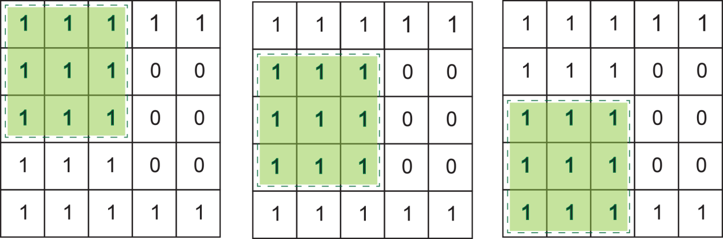

* The first square of defective products is a sub-matrix 3 x 3 starting at (0,0) and ending at (3,3)
* The second square of defective products is also a sub-matrix 3 x 3 starting at (1,0) and ending at (4,3)
* The third square of defective products is also a sub-matrix 3 x 3 starting at (2,0) and ending at (5,3)
* The size of the largest square of defective products is 3

**Function Description**

Complete the function findLargestSquareSize in the editor below.

findLargestSquareSize has the following parameter:

    int samples[n][n]:  a two-dimensional array of integers

**Returns:**

    int: an integer that represents the size of the largest square sub-matrix of defective products.

**Constraints**

* 0 ≤ n ≤ 500
* samples[i][j] is in the set {0, 1} (0 denotes anon-defective products and 1 denotes a defective product)

Input Format For Custom Testing

The first line contains an integer, n, the number of *rows (the number of samples)*.

The second line contains the integer, n, the number of columns (the number of products in a sample).  
Each line i of the n subsequent lines (where 0 ≤ i < n) contains n space-separated integers that describe samples[i].

Sample Case 0

**Sample Input For Custom Testing**

STDIN     Function

-----     --------

3 →   samples[] size n = 3

3     →   samples[i][] size n = 3

1 1 1 → samples=[[1,1,1],[1,1,0],[1,0,1]]

1 1 0

1 0 1

**Sample Output**

2

**Explanation**

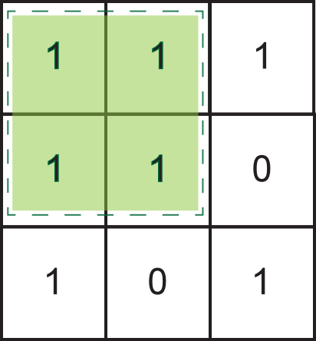

* The first  square of defective products is a sub-matrix 2 x 2 starting at (0,0) and ending at (1,1)
* The other square of defective products are a sub-matrix 1 x 1 at (2,0) ,  (0,2) and (2,2)
* The size of the largest square of defective products is 2

Sample Case 1

**Sample Input For Custom Testing**

STDIN     Function

-----     --------

3 →   samples[] size n = 3

3     →   samples[i][] size n = 3

0 1 1 → samples=[[0,1,1],[1,1,0],[1,0,1]]

1 1 0

1 0 1

**Sample Output**

1

**Explanation**

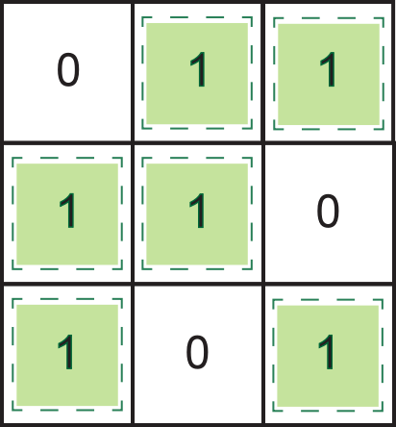

* All square of defective products are a sub-matrix 1 x 1 at (0,1) ,  (0,2) , (1,0), (1,1), (2,0) and (2,2).
* The size of the largest square of defective products is 1

package main

import (

    "fmt"

)

func findLargestSquareSize(rezasamples [][]*int*) *int* {

    n := len(rezasamples)

    maxSize := 0

    // membuat tabel dp untuk menyimpan ukuran sub-matriks persegi terbesar

    // produk cacat yang berakhir pada setiap posisi (i,j) dalam matriks sampel

    dp := make([][]*int*, n)

    for p := range dp {

        dp[p] = make([]*int*, n)

    }

    // menginisialisasi baris pertama dan kolom pertama dari tabel dp

    for p := 0; p < n; p++ {

        dp[p][0] = rezasamples[p][0]

        dp[0][p] = rezasamples[0][p]

    }

    // menghitung ukuran sub-matriks persegi terbesar dari produk cacat

    // berakhir pada setiap posisi (i,j) dalam matriks sampel

    for p := 1; p < n; p++ {

        for b := 1; b < n; b++ {

            if rezasamples[p][b] == 1 {

                dp[p][b] = 1 + min(dp[p-1][b-1], min(dp[p-1][b], dp[p][b-1]))

                if dp[p][b] > maxSize {

                    maxSize = dp[p][b]

                }

            }

        }

    }

    return maxSize

}

func min(a, b *int*) *int* {

    if a < b {

        return a

    }

    return b

}

func main() {

    // mendapatkan masukan

    var n *int*

    fmt.Scan(&n)

    rezasamples := make([][]*int*, n)

    for p := range rezasamples {

        rezasamples[p] = make([]*int*, n)

        for b := range rezasamples[p] {

            fmt.Scan(&rezasamples[p][b])

        }

    }

    //  menemukan ukuran sub-matriks persegi terbesar dari produk cacat

    maxSize := findLargestSquareSize(rezasamples)

    // mencetak hasilnya

    fmt.Println(maxSize)

}

